Pielikums

2023.gada __ saistošajiem noteikumiem

1.pielikums  
Ropažu novada pašvaldības domes 2022. gada 8. jūnija  
saistošajiem noteikumiem Nr. 25/22  
"Ropažu novada pašvaldības aģentūras "Saimnieks"  
sniegtie pakalpojumi"

**Ropažu novada Stopiņu pagastā sniegto komunālo pakalpojumu cenrādis**

|  |  |  |  |
| --- | --- | --- | --- |
| Nr. p.k. | Pakalpojums | Mērvienība | Maksa bez PVN* |
| 1 | Ūdensapgādes pakalpojums | EUR/m3 | 1.1607 |
| 2 | Kanalizācijas pakalpojums | EUR /m3 | 1.5784 |
| 3 | Decentralizētajās kanalizācijas sistēmās uzkrāto notekūdeņu un nosēdumu izvešanas pakalpojumu maksa | EEUR /1 izsaukums | 55.21 |

* norēķinos papildus aprēķina pievienotās vērtības nodokli normatīvajos aktos paredzētajā kārtībā un apmērā.

1. Ūdens daudzumu tiem pakalpojumu ņēmējiem, kuru objektos nav uzstādīti skaitītāji, aprēķina pēc spēkā esošajiem normatīvajiem aktiem kā m3 uz 1 cilvēku.

2. Siltumenerģijas maksa sastāv no pastāvīgās daļas un mainīgās daļas, kas aprēķināma pēc reālā energoresursu patēriņa.

2.1. Aģentūra katru gadu aprēķina siltumenerģijas apgādes pakalpojumu maksas (izcenojuma) projektu, vadoties pēc Sabiedrisko pakalpojumu regulēšanas komisijas vai citas tai pēc kompetences pielīdzināmas valsts institūcijas izstrādātas un apstiprinātas metodikas siltumenerģijas apgādes pakalpojumu tarifu aprēķināšanai, ciktāl metodika attiecināma uz Aģentūras kompetenci pakalpojumu maksas izstrādē un iesniedz apstiprināšanai Ropažu novada pašvaldībā.

2.1.1. izmantojot viendaļīgā siltumenerģijas tarifa aprēķināšanas metodi, kur siltumenerģijas mainīgās un pastāvīgās izmaksas ir attiecinātas uz lietotājiem pārdotās/nodotās siltumenerģijas vienību un Aģentūra saņem maksājumus par siltumenerģiju pēc noteiktā viendaļīgā tarifa par patērēto siltumenerģiju;

2.1.2. balstoties uz faktiskajām un ekonomiski pamatotām izmaksām izmaksu rašanās perioda laikā;

2.1.3. precīzi un pārskatāmi atspoguļojot siltumenerģijas daudzumu un kurināmā patēriņu, ražošanas izmaksas, pārvades un sadales izmaksas.

2.2. šī pielikuma 2.1. apakšpunktā noteikto siltumenerģijas apgādes pakalpojumu maksu apstiprina Ropažu novada pašvaldības dome.

2.3. Siltumenerģijas maksa tiek aprēķināta saskaņā ar šī pielikuma 1.pielikumā noteikto tarifa aprēķina kārtību.

2.4. Siltumenerģijas apgādes pakalpojumu tarifs pie dažādām kurināmā tirdzniecības cenām bez PVN tiek noteikts saskaņā ar šī pielikuma 2.pielikumu.

1. pielikums

**Ropažu novada pašvaldības aģentūras “Saimnieks” siltumenerģijas apgādes pakalpojuma tarifa aprēķina kārtība**

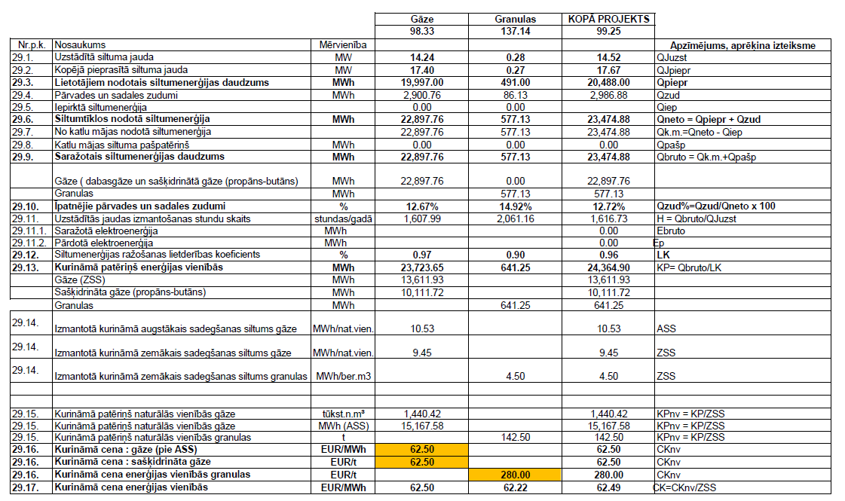

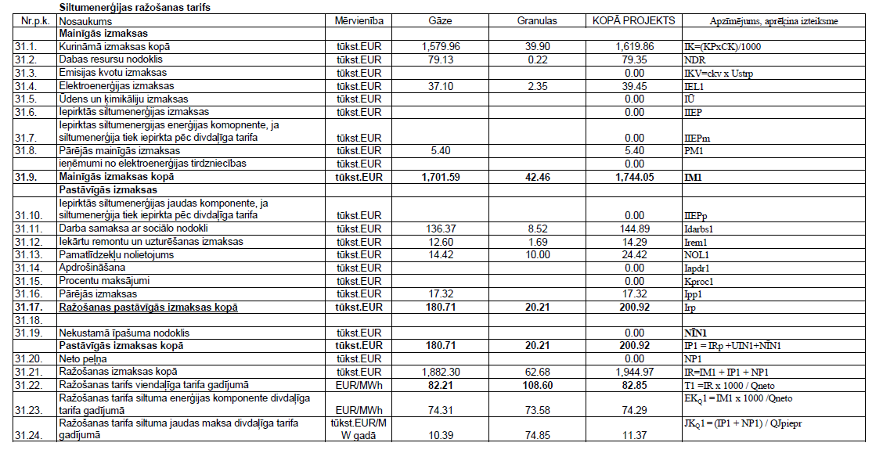

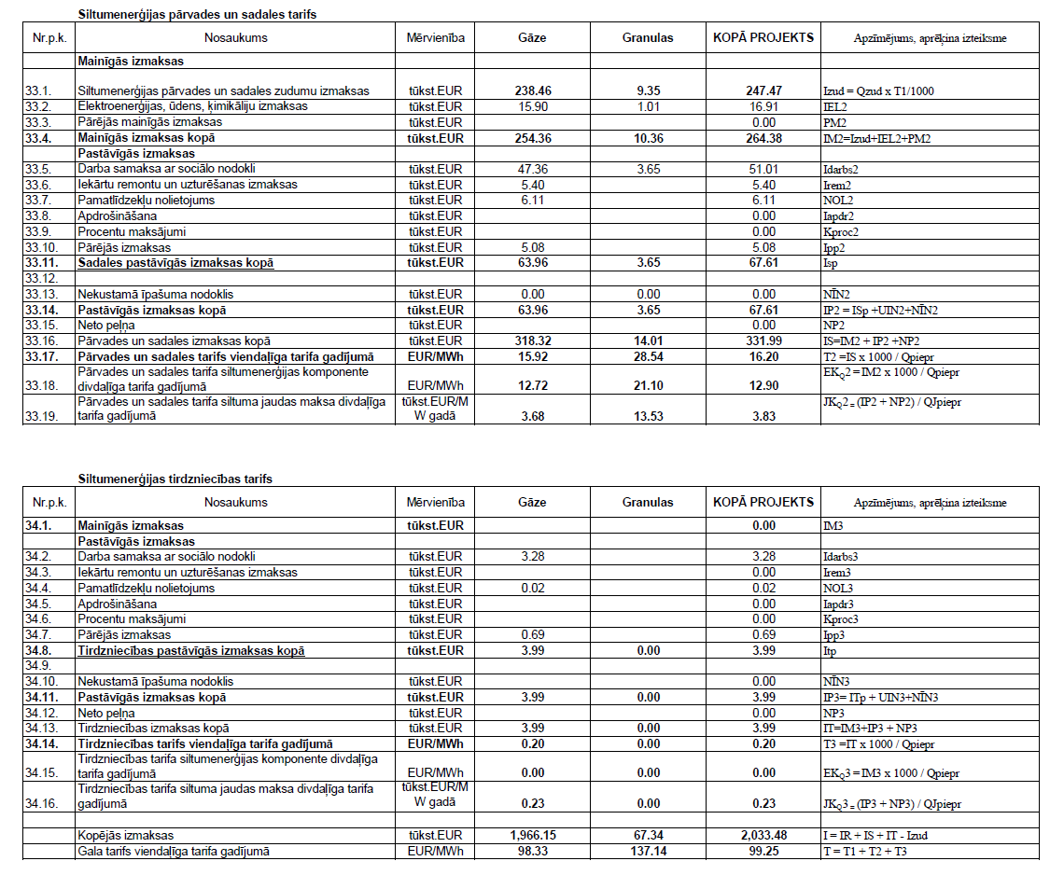

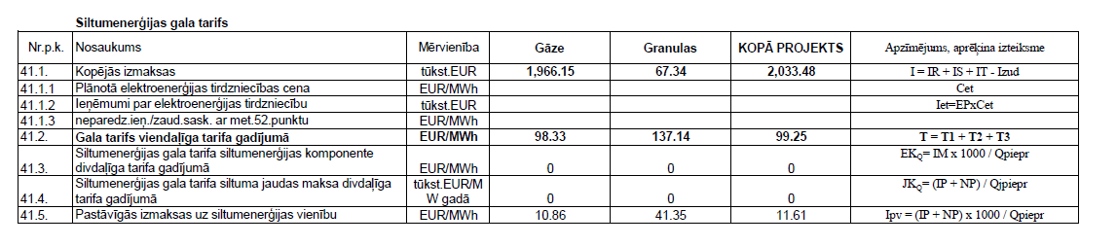

2.pielikums

**Ropažu novada pašvaldības aģentūras “Saimnieks” siltumenerģijas apgādes pakalpojuma tarifs (bez PVN) pie dažādām kurināmā cenām**

|  |  |  |  |  |
| --- | --- | --- | --- | --- |
| **Kurināmā vidējā cena (bez akcīzes**  **nodokļa)** | **Gala Tarifs** | t.sk. ražošanas  tarifs | t.sk. pārvades  tarifs | t.sk. tirdzniecības  tarifs |
| **EUR/MWh** | EUR/MWh | EUR/MWh | EUR/MWh | EUR/MWh |
| **17.49** | 42.32 | 33.17 | 8.96 | 0.20 |
| **17.99** | 42.95 | 33.72 | 9.04 | 0.20 |
| **18.49** | 43.59 | 34.27 | 9.12 | 0.20 |
| **18.99** | 44.22 | 34.82 | 9.20 | 0.20 |
| **19.49** | 44.85 | 35.37 | 9.28 | 0.20 |
| **19.99** | 45.48 | 35.93 | 9.36 | 0.20 |
| **20.49** | 46.12 | 36.48 | 9.44 | 0.20 |
| **20.99** | 46.75 | 37.03 | 9.52 | 0.20 |
| **21.49** | 47.38 | 37.58 | 9.60 | 0.20 |
| **21.99** | 48.01 | 38.13 | 9.68 | 0.20 |
| **22.49** | 48.65 | 38.69 | 9.77 | 0.20 |
| **22.99** | 49.28 | 39.24 | 9.85 | 0.20 |
| **23.49** | 49.91 | 39.79 | 9.93 | 0.20 |
| **23.99** | 50.54 | 40.34 | 10.01 | 0.20 |
| **24.49** | 51.18 | 40.89 | 10.09 | 0.20 |
| **24.99** | 51.81 | 41.45 | 10.17 | 0.20 |
| **25.49** | 52.44 | 42.00 | 10.25 | 0.20 |
| **25.99** | 53.07 | 42.55 | 10.33 | 0.20 |
| **26.49** | 53.71 | 43.10 | 10.41 | 0.20 |
| **26.99** | 54.34 | 43.65 | 10.49 | 0.20 |
| **27.49** | 54.97 | 44.21 | 10.57 | 0.20 |
| **27.99** | 55.60 | 44.76 | 10.65 | 0.20 |
| **28.49** | 56.24 | 45.31 | 10.73 | 0.20 |
| **28.99** | 56.87 | 45.86 | 10.81 | 0.20 |
| **29.49** | 57.50 | 46.42 | 10.89 | 0.20 |
| **29.99** | 58.13 | 46.97 | 10.97 | 0.20 |
| **30.49** | 58.77 | 47.52 | 11.05 | 0.20 |
| **30.99** | 59.40 | 48.07 | 11.13 | 0.20 |
| **31.49** | 60.03 | 48.62 | 11.21 | 0.20 |
| **31.99** | 60.67 | 49.18 | 11.29 | 0.20 |
| **32.49** | 61.30 | 49.73 | 11.37 | 0.20 |
| **32.99** | 61.93 | 50.28 | 11.46 | 0.20 |
| **33.49** | 62.56 | 50.83 | 11.54 | 0.20 |
| **33.99** | 63.20 | 51.38 | 11.62 | 0.20 |
| **34.49** | 63.83 | 51.94 | 11.70 | 0.20 |
| **34.99** | 64.46 | 52.49 | 11.78 | 0.20 |
| **35.49** | 65.09 | 53.04 | 11.86 | 0.20 |
| **35.99** | 65.73 | 53.59 | 11.94 | 0.20 |
| **36.49** | 66.36 | 54.14 | 12.02 | 0.20 |

|  |  |  |  |  |
| --- | --- | --- | --- | --- |
| **Kurināmā vidējā cena (bez akcīzes**  **nodokļa)** | **Gala Tarifs** | t.sk. ražošanas  tarifs | t.sk. pārvades  tarifs | t.sk. tirdzniecības  tarifs |
| **EUR/MWh** | EUR/MWh | EUR/MWh | EUR/MWh | EUR/MWh |
| **36.99** | 66.99 | 54.70 | 12.10 | 0.20 |
| **37.49** | 67.62 | 55.25 | 12.18 | 0.20 |
| **37.99** | 68.26 | 55.80 | 12.26 | 0.20 |
| **38.49** | 68.89 | 56.35 | 12.34 | 0.20 |
| **38.99** | 69.52 | 56.91 | 12.42 | 0.20 |
| **39.49** | 70.15 | 57.46 | 12.50 | 0.20 |
| **39.99** | 70.79 | 58.01 | 12.58 | 0.20 |
| **40.49** | 71.42 | 58.56 | 12.66 | 0.20 |
| **40.99** | 72.05 | 59.11 | 12.74 | 0.20 |
| **41.49** | 72.68 | 59.67 | 12.82 | 0.20 |
| **41.99** | 73.32 | 60.22 | 12.90 | 0.20 |
| **42.49** | 73.95 | 60.77 | 12.98 | 0.20 |
| **42.99** | 74.58 | 61.32 | 13.07 | 0.20 |
| **43.49** | 75.21 | 61.87 | 13.15 | 0.20 |
| **43.99** | 75.85 | 62.43 | 13.23 | 0.20 |
| **44.49** | 76.48 | 62.98 | 13.31 | 0.20 |
| **44.99** | 77.11 | 63.53 | 13.39 | 0.20 |
| **45.49** | 77.74 | 64.08 | 13.47 | 0.20 |
| **45.99** | 78.38 | 64.63 | 13.55 | 0.20 |
| **46.49** | 79.01 | 65.19 | 13.63 | 0.20 |
| **46.99** | 79.64 | 65.74 | 13.71 | 0.20 |
| **47.49** | 80.28 | 66.29 | 13.79 | 0.20 |
| **47.99** | 80.91 | 66.84 | 13.87 | 0.20 |
| **48.49** | 81.54 | 67.39 | 13.95 | 0.20 |
| **48.99** | 82.17 | 67.95 | 14.03 | 0.20 |
| **49.49** | 82.81 | 68.50 | 14.11 | 0.20 |
| **49.99** | 83.44 | 69.05 | 14.19 | 0.20 |
| **50.49** | 84.07 | 69.60 | 14.27 | 0.20 |
| **50.99** | 84.70 | 70.16 | 14.35 | 0.20 |
| **51.49** | 85.34 | 70.71 | 14.43 | 0.20 |
| **51.99** | 85.97 | 71.26 | 14.51 | 0.20 |
| **52.49** | 86.60 | 71.81 | 14.59 | 0.20 |
| **52.99** | 87.23 | 72.36 | 14.67 | 0.20 |
| **53.49** | 87.87 | 72.92 | 14.76 | 0.20 |
| **53.99** | 88.50 | 73.47 | 14.84 | 0.20 |
| **54.49** | 89.13 | 74.02 | 14.92 | 0.20 |
| **54.99** | 89.76 | 74.57 | 15.00 | 0.20 |
| **55.49** | 90.40 | 75.12 | 15.08 | 0.20 |
| **55.99** | 91.03 | 75.68 | 15.16 | 0.20 |
| **56.49** | 91.66 | 76.23 | 15.24 | 0.20 |
| **56.99** | 92.29 | 76.78 | 15.32 | 0.20 |
| **57.49** | 92.93 | 77.33 | 15.40 | 0.20 |

|  |  |  |  |  |
| --- | --- | --- | --- | --- |
| **Kurināmā vidējā cena (bez akcīzes**  **nodokļa)** | **Gala Tarifs** | t.sk. ražošanas  tarifs | t.sk. pārvades  tarifs | t.sk. tirdzniecības  tarifs |
| **EUR/MWh** | EUR/MWh | EUR/MWh | EUR/MWh | EUR/MWh |
| **57.99** | 93.56 | 77.88 | 15.48 | 0.20 |
| **58.49** | 94.19 | 78.44 | 15.56 | 0.20 |
| **58.99** | 94.82 | 78.99 | 15.64 | 0.20 |
| **59.49** | 95.46 | 79.54 | 15.72 | 0.20 |
| **59.99** | 96.09 | 80.09 | 15.80 | 0.20 |
| **60.49** | 96.72 | 80.65 | 15.88 | 0.20 |
| **60.99** | 97.35 | 81.20 | 15.96 | 0.20 |
| **61.49** | 97.99 | 81.75 | 16.04 | 0.20 |
| **61.99** | 98.62 | 82.30 | 16.12 | 0.20 |
| **62.49** | **99.25** | **82.85** | 16.20 | **0.20** |
| **62.99** | 99.89 | 83.41 | 16.28 | 0.20 |
| **63.49** | 100.52 | 83.96 | 16.37 | 0.20 |
| **63.99** | 101.15 | 84.51 | 16.45 | 0.20 |
| **64.49** | 101.78 | 85.06 | 16.53 | 0.20 |
| **64.99** | 102.42 | 85.61 | 16.61 | 0.20 |
| **65.49** | 103.05 | 86.17 | 16.69 | 0.20 |
| **65.99** | 103.68 | 86.72 | 16.77 | 0.20 |
| **66.49** | 104.31 | 87.27 | 16.85 | 0.20 |
| **66.99** | 104.95 | 87.82 | 16.93 | 0.20 |
| **67.49** | 105.58 | 88.37 | 17.01 | 0.20 |
| **67.99** | 106.21 | 88.93 | 17.09 | 0.20 |
| **68.49** | 106.84 | 89.48 | 17.17 | 0.20 |
| **68.99** | 107.48 | 90.03 | 17.25 | 0.20 |
| **69.49** | 108.11 | 90.58 | 17.33 | 0.20 |
| **69.99** | 108.74 | 91.13 | 17.41 | 0.20 |
| **70.49** | 109.37 | 91.69 | 17.49 | 0.20 |
| **70.99** | 110.01 | 92.24 | 17.57 | 0.20 |
| **71.49** | 110.64 | 92.79 | 17.65 | 0.20 |
| **71.99** | 111.27 | 93.34 | 17.73 | 0.20 |
| **72.49** | 111.90 | 93.90 | 17.81 | 0.20 |
| **72.99** | 112.54 | 94.45 | 17.89 | 0.20 |
| **73.49** | 113.17 | 95.00 | 17.97 | 0.20 |
| **73.99** | 113.80 | 95.55 | 18.06 | 0.20 |
| **74.49** | 114.43 | 96.10 | 18.14 | 0.20 |
| **74.99** | 115.07 | 96.66 | 18.22 | 0.20 |
| **75.49** | 115.70 | 97.21 | 18.30 | 0.20 |
| **75.99** | 116.33 | 97.76 | 18.38 | 0.20 |
| **76.49** | 116.96 | 98.31 | 18.46 | 0.20 |
| **76.99** | 117.60 | 98.86 | 18.54 | 0.20 |
| **77.49** | 118.23 | 99.42 | 18.62 | 0.20 |
| **77.99** | 118.86 | 99.97 | 18.70 | 0.20 |
| **78.49** | 119.49 | 100.52 | 18.78 | 0.20 |

|  |  |  |  |  |
| --- | --- | --- | --- | --- |
| **Kurināmā vidējā cena (bez akcīzes**  **nodokļa)** | **Gala Tarifs** | t.sk. ražošanas  tarifs | t.sk. pārvades  tarifs | t.sk. tirdzniecības  tarifs |
| **EUR/MWh** | EUR/MWh | EUR/MWh | EUR/MWh | EUR/MWh |
| **78.99** | 120.13 | 101.07 | 18.86 | 0.20 |
| **79.49** | 120.76 | 101.62 | 18.94 | 0.20 |
| **79.99** | 121.39 | 102.18 | 19.02 | 0.20 |
| **80.49** | 122.03 | 102.73 | 19.10 | 0.20 |
| **80.99** | 122.66 | 103.28 | 19.18 | 0.20 |
| **81.49** | 123.29 | 103.83 | 19.26 | 0.20 |
| **81.99** | 123.92 | 104.38 | 19.34 | 0.20 |
| **82.49** | 124.56 | 104.94 | 19.42 | 0.20 |
| **82.99** | 125.19 | 105.49 | 19.50 | 0.20 |
| **83.49** | 125.82 | 106.04 | 19.58 | 0.20 |
| **83.99** | 126.45 | 106.59 | 19.67 | 0.20 |
| **84.49** | 127.09 | 107.15 | 19.75 | 0.20 |
| **84.99** | 127.72 | 107.70 | 19.83 | 0.20 |
| **85.49** | 128.35 | 108.25 | 19.91 | 0.20 |
| **85.99** | 128.98 | 108.80 | 19.99 | 0.20 |
| **86.49** | 129.62 | 109.35 | 20.07 | 0.20 |
| **86.99** | 130.25 | 109.91 | 20.15 | 0.20 |
| **87.49** | 130.88 | 110.46 | 20.23 | 0.20 |
| **87.99** | 131.51 | 111.01 | 20.31 | 0.20 |
| **88.49** | 132.15 | 111.56 | 20.39 | 0.20 |
| **88.99** | 132.78 | 112.11 | 20.47 | 0.20 |
| **89.49** | 133.41 | 112.67 | 20.55 | 0.20 |
| **89.99** | 134.04 | 113.22 | 20.63 | 0.20 |
| **90.49** | 134.68 | 113.77 | 20.71 | 0.20 |
| **90.99** | 135.31 | 114.32 | 20.79 | 0.20 |
| **91.49** | 135.94 | 114.87 | 20.87 | 0.20 |
| **91.99** | 136.57 | 115.43 | 20.95 | 0.20 |
| **92.49** | 137.21 | 115.98 | 21.03 | 0.20 |
| **92.99** | 137.84 | 116.53 | 21.11 | 0.20 |
| **93.49** | 138.47 | 117.08 | 21.19 | 0.20 |
| **93.99** | 139.10 | 117.64 | 21.27 | 0.20 |
| **94.49** | 139.74 | 118.19 | 21.36 | 0.20 |
| **94.99** | 140.37 | 118.74 | 21.44 | 0.20 |
| **95.49** | 141.00 | 119.29 | 21.52 | 0.20 |
| **95.99** | 141.64 | 119.84 | 21.60 | 0.20 |
| **96.49** | 142.27 | 120.40 | 21.68 | 0.20 |
| **96.99** | 142.90 | 120.95 | 21.76 | 0.20 |
| **97.49** | 143.53 | 121.50 | 21.84 | 0.20 |
| **97.99** | 144.17 | 122.05 | 21.92 | 0.20 |
| **98.49** | 144.80 | 122.60 | 22.00 | 0.20 |
| **98.99** | 145.43 | 123.16 | 22.08 | 0.20 |
| **99.49** | 146.06 | 123.71 | 22.16 | 0.20 |

|  |  |  |  |  |
| --- | --- | --- | --- | --- |
| **Kurināmā vidējā cena (bez akcīzes**  **nodokļa)** | **Gala Tarifs** | t.sk. ražošanas  tarifs | t.sk. pārvades  tarifs | t.sk. tirdzniecības  tarifs |
| **EUR/MWh** | EUR/MWh | EUR/MWh | EUR/MWh | EUR/MWh |
| **99.99** | 146.70 | 124.26 | 22.24 | 0.20 |
| **100.49** | 147.33 | 124.81 | 22.32 | 0.20 |
| **100.99** | 147.96 | 125.36 | 22.40 | 0.20 |
| **101.49** | 148.59 | 125.92 | 22.48 | 0.20 |
| **101.99** | 149.23 | 126.47 | 22.56 | 0.20 |
| **102.49** | 149.86 | 127.02 | 22.64 | 0.20 |
| **102.99** | 150.49 | 127.57 | 22.72 | 0.20 |
| **103.49** | 151.12 | 128.12 | 22.80 | 0.20 |
| **103.99** | 151.76 | 128.68 | 22.88 | 0.20 |
| **104.49** | 152.39 | 129.23 | 22.97 | 0.20 |
| **104.99** | 153.02 | 129.78 | 23.05 | 0.20 |
| **105.49** | 153.65 | 130.33 | 23.13 | 0.20 |
| **105.99** | 154.29 | 130.89 | 23.21 | 0.20 |
| **106.49** | 154.92 | 131.44 | 23.29 | 0.20 |
| **106.99** | 155.55 | 131.99 | 23.37 | 0.20 |
| **107.49** | 156.18 | 132.54 | 23.45 | 0.20 |
| **107.99** | 156.82 | 133.09 | 23.53 | 0.20 |
| **108.49** | 157.45 | 133.65 | 23.61 | 0.20 |
| **108.99** | 158.08 | 134.20 | 23.69 | 0.20 |
| **109.49** | 158.71 | 134.75 | 23.77 | 0.20 |
| **109.99** | 159.35 | 135.30 | 23.85 | 0.20 |
| **110.49** | 159.98 | 135.85 | 23.93 | 0.20 |
| **110.99** | 160.61 | 136.41 | 24.01 | 0.20 |
| **111.49** | 161.25 | 136.96 | 24.09 | 0.20 |
| **111.99** | 161.88 | 137.51 | 24.17 | 0.20 |
| **112.49** | 162.51 | 138.06 | 24.25 | 0.20 |
| **112.99** | 163.14 | 138.61 | 24.33 | 0.20 |
| **113.49** | 163.78 | 139.17 | 24.41 | 0.20 |
| **113.99** | 164.41 | 139.72 | 24.49 | 0.20 |
| **114.49** | 165.04 | 140.27 | 24.57 | 0.20 |
| **114.99** | 165.67 | 140.82 | 24.66 | 0.20 |
| **115.49** | 166.31 | 141.38 | 24.74 | 0.20 |
| **115.99** | 166.94 | 141.93 | 24.82 | 0.20 |
| **116.49** | 167.57 | 142.48 | 24.90 | 0.20 |
| **116.99** | 168.20 | 143.03 | 24.98 | 0.20 |
| **117.49** | 168.84 | 143.58 | 25.06 | 0.20 |
| **117.99** | 169.47 | 144.14 | 25.14 | 0.20 |
| **118.49** | 170.10 | 144.69 | 25.22 | 0.20 |
| **118.99** | 170.73 | 145.24 | 25.30 | 0.20 |
| **119.49** | 171.37 | 145.79 | 25.38 | 0.20 |
| **119.99** | 172.00 | 146.34 | 25.46 | 0.20 |
| **120.49** | 172.63 | 146.90 | 25.54 | 0.20 |

|  |  |  |  |  |
| --- | --- | --- | --- | --- |
| **Kurināmā vidējā cena (bez akcīzes**  **nodokļa)** | **Gala Tarifs** | t.sk. ražošanas  tarifs | t.sk. pārvades  tarifs | t.sk. tirdzniecības  tarifs |
| **EUR/MWh** | EUR/MWh | EUR/MWh | EUR/MWh | EUR/MWh |
| **120.99** | 173.26 | 147.45 | 25.62 | 0.20 |
| **121.49** | 173.90 | 148.00 | 25.70 | 0.20 |
| **121.99** | 174.53 | 148.55 | 25.78 | 0.20 |
| **122.49** | 175.16 | 149.10 | 25.86 | 0.20 |
| **122.99** | 175.79 | 149.66 | 25.94 | 0.20 |
| **123.49** | 176.43 | 150.21 | 26.02 | 0.20 |
| **123.99** | 177.06 | 150.76 | 26.10 | 0.20 |
| **124.49** | 177.69 | 151.31 | 26.18 | 0.20 |
| **124.99** | 178.32 | 151.86 | 26.27 | 0.20 |
| **125.49** | 178.96 | 152.42 | 26.35 | 0.20 |
| **125.99** | 179.59 | 152.97 | 26.43 | 0.20 |
| **126.49** | 180.22 | 153.52 | 26.51 | 0.20 |
| **126.99** | 180.86 | 154.07 | 26.59 | 0.20 |
| **127.49** | 181.49 | 154.63 | 26.67 | 0.20 |
| **127.99** | 182.12 | 155.18 | 26.75 | 0.20 |
| **128.49** | 182.75 | 155.73 | 26.83 | 0.20 |
| **128.99** | 183.39 | 156.28 | 26.91 | 0.20 |
| **129.49** | 184.02 | 156.83 | 26.99 | 0.20 |
| **129.99** | 184.65 | 157.39 | 27.07 | 0.20 |
| **130.49** | 185.28 | 157.94 | 27.15 | 0.20 |
| **130.99** | 185.92 | 158.49 | 27.23 | 0.20 |
| **131.49** | 186.55 | 159.04 | 27.31 | 0.20 |
| **131.99** | 187.18 | 159.59 | 27.39 | 0.20 |
| **132.49** | 187.81 | 160.15 | 27.47 | 0.20 |
| **132.99** | 188.45 | 160.70 | 27.55 | 0.20 |
| **133.49** | 189.08 | 161.25 | 27.63 | 0.20 |
| **133.99** | 189.71 | 161.80 | 27.71 | 0.20 |
| **134.49** | 190.34 | 162.35 | 27.79 | 0.20 |
| **134.99** | 190.98 | 162.91 | 27.87 | 0.20 |
| **135.49** | 191.61 | 163.46 | 27.96 | 0.20 |
| **135.99** | 192.24 | 164.01 | 28.04 | 0.20 |
| **136.49** | 192.87 | 164.56 | 28.12 | 0.20 |
| **136.99** | 193.51 | 165.11 | 28.20 | 0.20 |
| **137.49** | 194.14 | 165.67 | 28.28 | 0.20 |
| **137.99** | 194.77 | 166.22 | 28.36 | 0.20 |
| **138.49** | 195.40 | 166.77 | 28.44 | 0.20 |
| **138.99** | 196.04 | 167.32 | 28.52 | 0.20 |
| **139.49** | 196.67 | 167.88 | 28.60 | 0.20 |
| **139.99** | 197.30 | 168.43 | 28.68 | 0.20 |
| **140.49** | 197.93 | 168.98 | 28.76 | 0.20 |
| **140.99** | 198.57 | 169.53 | 28.84 | 0.20 |
| **141.49** | 199.20 | 170.08 | 28.92 | 0.20 |

|  |  |  |  |  |
| --- | --- | --- | --- | --- |
| **Kurināmā vidējā cena (bez akcīzes**  **nodokļa)** | **Gala Tarifs** | t.sk. ražošanas  tarifs | t.sk. pārvades  tarifs | t.sk. tirdzniecības  tarifs |
| **EUR/MWh** | EUR/MWh | EUR/MWh | EUR/MWh | EUR/MWh |
| **141.99** | 199.83 | 170.64 | 29.00 | 0.20 |
| **142.49** | 200.47 | 171.19 | 29.08 | 0.20 |
| **142.99** | 201.10 | 171.74 | 29.16 | 0.20 |
| **143.49** | 201.73 | 172.29 | 29.24 | 0.20 |
| **143.99** | 202.36 | 172.84 | 29.32 | 0.20 |
| **144.49** | 203.00 | 173.40 | 29.40 | 0.20 |
| **144.99** | 203.63 | 173.95 | 29.48 | 0.20 |
| **145.49** | 204.26 | 174.50 | 29.57 | 0.20 |
| **145.99** | 204.89 | 175.05 | 29.65 | 0.20 |
| **146.49** | 205.53 | 175.60 | 29.73 | 0.20 |
| **146.99** | 206.16 | 176.16 | 29.81 | 0.20 |
| **147.49** | 206.79 | 176.71 | 29.89 | 0.20 |
| **147.99** | 207.42 | 177.26 | 29.97 | 0.20 |
| **148.49** | 208.06 | 177.81 | 30.05 | 0.20 |
| **148.99** | 208.69 | 178.37 | 30.13 | 0.20 |
| **149.49** | 209.32 | 178.92 | 30.21 | 0.20 |
| **149.99** | 209.95 | 179.47 | 30.29 | 0.20 |
| **150.49** | 210.59 | 180.02 | 30.37 | 0.20 |
| **150.99** | 211.22 | 180.57 | 30.45 | 0.20 |
| **151.49** | 211.85 | 181.13 | 30.53 | 0.20 |
| **151.99** | 212.48 | 181.68 | 30.61 | 0.20 |
| **152.49** | 213.12 | 182.23 | 30.69 | 0.20 |
| **152.99** | 213.75 | 182.78 | 30.77 | 0.20 |
| **153.49** | 214.38 | 183.33 | 30.85 | 0.20 |
| **153.99** | 215.01 | 183.89 | 30.93 | 0.20 |
| **154.49** | 215.65 | 184.44 | 31.01 | 0.20 |
| **154.99** | 216.28 | 184.99 | 31.09 | 0.20 |
| **155.49** | 216.91 | 185.54 | 31.17 | 0.20 |
| **155.99** | 217.54 | 186.09 | 31.26 | 0.20 |
| **156.49** | 218.18 | 186.65 | 31.34 | 0.20 |
| **156.99** | 218.81 | 187.20 | 31.42 | 0.20 |
| **157.49** | 219.44 | 187.75 | 31.50 | 0.20 |
| **157.99** | 220.08 | 188.30 | 31.58 | 0.20 |
| **158.49** | 220.71 | 188.85 | 31.66 | 0.20 |
| **158.99** | 221.34 | 189.41 | 31.74 | 0.20 |
| **159.49** | 221.97 | 189.96 | 31.82 | 0.20 |
| **159.99** | 222.61 | 190.51 | 31.90 | 0.20 |
| **160.49** | 223.24 | 191.06 | 31.98 | 0.20 |
| **160.99** | 223.87 | 191.62 | 32.06 | 0.20 |
| **161.49** | 224.50 | 192.17 | 32.14 | 0.20 |
| **161.99** | 225.14 | 192.72 | 32.22 | 0.20 |
| **162.49** | 225.77 | 193.27 | 32.30 | 0.20 |

|  |  |  |  |  |
| --- | --- | --- | --- | --- |
| **Kurināmā vidējā cena (bez akcīzes**  **nodokļa)** | **Gala Tarifs** | t.sk. ražošanas  tarifs | t.sk. pārvades  tarifs | t.sk. tirdzniecības  tarifs |
| **EUR/MWh** | EUR/MWh | EUR/MWh | EUR/MWh | EUR/MWh |
| **162.99** | 226.40 | 193.82 | 32.38 | 0.20 |
| **163.49** | 227.03 | 194.38 | 32.46 | 0.20 |
| **163.99** | 227.67 | 194.93 | 32.54 | 0.20 |
| **164.49** | 228.30 | 195.48 | 32.62 | 0.20 |
| **164.99** | 228.93 | 196.03 | 32.70 | 0.20 |
| **165.49** | 229.56 | 196.58 | 32.78 | 0.20 |
| **165.99** | 230.20 | 197.14 | 32.87 | 0.20 |
| **166.49** | 230.83 | 197.69 | 32.95 | 0.20 |
| **166.99** | 231.46 | 198.24 | 33.03 | 0.20 |
| **167.49** | 232.09 | 198.79 | 33.11 | 0.20 |
| **167.99** | 232.73 | 199.34 | 33.19 | 0.20 |
| **168.49** | 233.36 | 199.90 | 33.27 | 0.20 |
| **168.99** | 233.99 | 200.45 | 33.35 | 0.20 |
| **169.49** | 234.62 | 201.00 | 33.43 | 0.20 |
| **169.99** | 235.26 | 201.55 | 33.51 | 0.20 |
| **170.49** | 235.89 | 202.11 | 33.59 | 0.20 |
| **170.99** | 236.52 | 202.66 | 33.67 | 0.20 |
| **171.49** | 237.15 | 203.21 | 33.75 | 0.20 |
| **171.99** | 237.79 | 203.76 | 33.83 | 0.20 |
| **172.49** | 238.42 | 204.31 | 33.91 | 0.20 |
| **172.99** | 239.05 | 204.87 | 33.99 | 0.20 |
| **173.49** | 239.68 | 205.42 | 34.07 | 0.20 |
| **173.99** | 240.32 | 205.97 | 34.15 | 0.20 |
| **174.49** | 240.95 | 206.52 | 34.23 | 0.20 |
| **174.99** | 241.58 | 207.07 | 34.31 | 0.20 |
| **175.49** | 242.22 | 207.63 | 34.39 | 0.20 |
| **175.99** | 242.85 | 208.18 | 34.47 | 0.20 |
| **176.49** | 243.48 | 208.73 | 34.56 | 0.20 |
| **176.99** | 244.11 | 209.28 | 34.64 | 0.20 |
| **177.49** | 244.75 | 209.83 | 34.72 | 0.20 |
| **177.99** | 245.38 | 210.39 | 34.80 | 0.20 |
| **178.49** | 246.01 | 210.94 | 34.88 | 0.20 |
| **178.99** | 246.64 | 211.49 | 34.96 | 0.20 |
| **179.49** | 247.28 | 212.04 | 35.04 | 0.20 |
| **179.99** | 247.91 | 212.59 | 35.12 | 0.20 |
| **180.49** | 248.54 | 213.15 | 35.20 | 0.20 |
| **180.99** | 249.17 | 213.70 | 35.28 | 0.20 |
| **181.49** | 249.81 | 214.25 | 35.36 | 0.20 |
| **181.99** | 250.44 | 214.80 | 35.44 | 0.20 |
| **182.49** | 251.07 | 215.36 | 35.52 | 0.20 |
| **182.99** | 251.70 | 215.91 | 35.60 | 0.20 |
| **183.49** | 252.34 | 216.46 | 35.68 | 0.20 |

|  |  |  |  |  |
| --- | --- | --- | --- | --- |
| **Kurināmā vidējā cena (bez akcīzes**  **nodokļa)** | **Gala Tarifs** | t.sk. ražošanas  tarifs | t.sk. pārvades  tarifs | t.sk. tirdzniecības  tarifs |
| **EUR/MWh** | EUR/MWh | EUR/MWh | EUR/MWh | EUR/MWh |
| **183.99** | 252.97 | 217.01 | 35.76 | 0.20 |
| **184.49** | 253.60 | 217.56 | 35.84 | 0.20 |
| **184.99** | 254.23 | 218.12 | 35.92 | 0.20 |
| **185.49** | 254.87 | 218.67 | 36.00 | 0.20 |
| **185.99** | 255.50 | 219.22 | 36.08 | 0.20 |
| **186.49** | 256.13 | 219.77 | 36.17 | 0.20 |
| **186.99** | 256.76 | 220.32 | 36.25 | 0.20 |
| **187.49** | 257.40 | 220.88 | 36.33 | 0.20 |
| **187.99** | 258.03 | 221.43 | 36.41 | 0.20 |
| **188.49** | 258.66 | 221.98 | 36.49 | 0.20 |
| **188.99** | 259.29 | 222.53 | 36.57 | 0.20 |
| **189.49** | 259.93 | 223.08 | 36.65 | 0.20 |
| **189.99** | 260.56 | 223.64 | 36.73 | 0.20 |
| **190.49** | 261.19 | 224.19 | 36.81 | 0.20 |
| **190.99** | 261.83 | 224.74 | 36.89 | 0.20 |
| **191.49** | 262.46 | 225.29 | 36.97 | 0.20 |
| **191.99** | 263.09 | 225.85 | 37.05 | 0.20 |
| **192.49** | 263.72 | 226.40 | 37.13 | 0.20 |
| **192.99** | 264.36 | 226.95 | 37.21 | 0.20 |
| **193.49** | 264.99 | 227.50 | 37.29 | 0.20 |
| **193.99** | 265.62 | 228.05 | 37.37 | 0.20 |
| **194.49** | 266.25 | 228.61 | 37.45 | 0.20 |
| **194.99** | 266.89 | 229.16 | 37.53 | 0.20 |
| **195.49** | 267.52 | 229.71 | 37.61 | 0.20 |
| **195.99** | 268.15 | 230.26 | 37.69 | 0.20 |
| **196.49** | 268.78 | 230.81 | 37.77 | 0.20 |
| **196.99** | 269.42 | 231.37 | 37.86 | 0.20 |
| **197.49** | 270.05 | 231.92 | 37.94 | 0.20 |
| **197.99** | 270.68 | 232.47 | 38.02 | 0.20 |
| **198.49** | 271.31 | 233.02 | 38.10 | 0.20 |
| **198.99** | 271.95 | 233.57 | 38.18 | 0.20 |
| **199.49** | 272.58 | 234.13 | 38.26 | 0.20 |
| **199.99** | 273.21 | 234.68 | 38.34 | 0.20 |
| **200.49** | 273.84 | 235.23 | 38.42 | 0.20 |
| **200.99** | 274.48 | 235.78 | 38.50 | 0.20 |
| **201.49** | 275.11 | 236.33 | 38.58 | 0.20 |
| **201.99** | 275.74 | 236.89 | 38.66 | 0.20 |
| **202.49** | 276.37 | 237.44 | 38.74 | 0.20 |
| **202.99** | 277.01 | 237.99 | 38.82 | 0.20 |
| **203.49** | 277.64 | 238.54 | 38.90 | 0.20 |
| **203.99** | 278.27 | 239.10 | 38.98 | 0.20 |
| **204.49** | 278.90 | 239.65 | 39.06 | 0.20 |

|  |  |  |  |  |
| --- | --- | --- | --- | --- |
| **Kurināmā vidējā cena (bez akcīzes**  **nodokļa)** | **Gala Tarifs** | t.sk. ražošanas  tarifs | t.sk. pārvades  tarifs | t.sk. tirdzniecības  tarifs |
| **EUR/MWh** | EUR/MWh | EUR/MWh | EUR/MWh | EUR/MWh |
| **204.99** | 279.54 | 240.20 | 39.14 | 0.20 |
| **205.49** | 280.17 | 240.75 | 39.22 | 0.20 |
| **205.99** | 280.80 | 241.30 | 39.30 | 0.20 |
| **206.49** | 281.44 | 241.86 | 39.38 | 0.20 |
| **206.99** | 282.07 | 242.41 | 39.47 | 0.20 |
| **207.49** | 282.70 | 242.96 | 39.55 | 0.20 |
| **207.99** | 283.33 | 243.51 | 39.63 | 0.20 |
| **208.49** | 283.97 | 244.06 | 39.71 | 0.20 |
| **208.99** | 284.60 | 244.62 | 39.79 | 0.20 |
| **209.49** | 285.23 | 245.17 | 39.87 | 0.20 |
| **209.99** | 285.86 | 245.72 | 39.95 | 0.20 |
| **210.49** | 286.50 | 246.27 | 40.03 | 0.20 |
| **210.99** | 287.13 | 246.82 | 40.11 | 0.20 |
| **211.49** | 287.76 | 247.38 | 40.19 | 0.20 |
| **211.99** | 288.39 | 247.93 | 40.27 | 0.20 |
| **212.49** | 289.03 | 248.48 | 40.35 | 0.20 |